How to Deal with the Spatial Paradigm
Written by special contributor Christian Paratschek on 2004-06-30 18:56:56 EST
Gnome 2.6's recent switch from navigational to spatial mode within Nautilus was highly controversial. As probably most of you know, "navigational" means browsing through folders in the same window, just like it works in Windows 2000/XP or in Konqueror. "Spatial", on the other hand, is a very different concept of managing your files. Not only does each folder open in its own window, but the windows also memorize their exact position and size on the desktop.
This concept is taken from real life: folders that come up the same way each time are much more like "real objects", and it's easier for people to deal with those than with a highly theoretical file hierarchy. There's a really good article at arstechnica about this matter. I recommend this article to everyone who is interested in learning about the navigational/spatial issue.
I have read a lot of reasons pro and contra spatial and navigational modes during the last weeks, especially here on osnews. Many people compare the spatial Nautilus to Windows Explorers (terrible) behaviour in Win95 - changing the setting to "open new folder in the same window" was probably the first thing that most of us did after completing a Win95 install. I know. I did. A lot of people complain because they feel that the Gnome project forced this decision on them, others flame back, saying that it's easy enough to change Nautilus back to navigational mode. As I said, this is a highly controversial issue.
Why do I write this article? There are mainly two reasons. First, I have a lot of experience with computer newbies. I worked as IT-support for two years and now I am self-employed, also supporting and administrating computers and small networks. I mostly have to deal with computer illiterates and office people who think that "the internet is the blue "e" down there", people who think that ms office is part of windows and writing texts is only possible with MS Word. Well, you get it. Therefore, I am pretty sure I know a lot about usability and ease of use. I am constantly configuring desktops for users, constantly trying to improve their computing experience. And "improving" means "making it easier" most of the time. Second, I myself, am an advanced computer user who has dealt with file hierarchies ever since i first found the option to open a new folder in the same window in Win95. I am sure this article can be helpful to a lot of you intermediate-to-expert users who can't stand spatial nautilus because you are so used to your file hierarchy. Well, let's see how it worked out for me...
First, I wanna tell you what I usually do to make a computer easy and consistent to use for a newbie: when I set up a computer for anyone of my clients, I usually do that in Windows XP. There are some tricks I use to make the computing experience as easy as possible for the user: I clean the desktop and delete all automatically created shortcuts, except for the tray icon and the "my computer" icon. Then i turn on the quick launch bar. Shortcuts to programs should always be there so that the users can switch between programs without having to minimize all the open windows just to get to the icon. Then I change the location of the "My Documents"-folder from c:\documents and settings\blablabla to another partition. This is of course just a way to separate user data from system data, nothing that improves the users computing experience.
I try to avoid anything that even remotely reminds the user of a file hierarchy. I have seen, over and over again, that novice users (and often enough users who have used computers for several years!) don't get the concept of a file hierarchy. They get lost as soon as they open Windows Explorer. They call me because they don't find the attachment they just saved from an email. Believe me - it happens. It happens over and over again. File hierarchies are bad for anyone who can be content with a handful of folders.
So how do I avoid file hierarchies in Windows? To do that, I create some folders in "My Documents", ("My Music" and "My Pictures" are there automatically, so I just have to add one for new files, one for documents, maybe one for videos, maybe 1-2 more, depending on the needs of the user). The one for the new stuff is called "new". After creating "new" I open all programs that could possibly want to save files on the computer (browser, email, cd-ripper, office programs,...) and configure them to save to this folder. Then I put a shortcut to this folder on the desktop. Despite being navigational, Windows includes some spatial features (folders memorize size and position) that are just enough for me now. I open the "new"-folder, resize it to a reasonable size and put it somewhere on the left of the screen. (see screenshot new_folder.jpg).
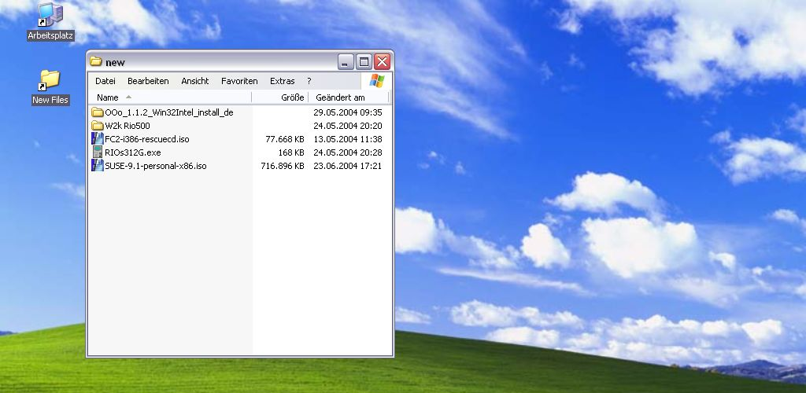
Notice that i strip Explorer of all the unnecessary features? It looks a lot like the new Nautilus, eh? Then I put shortcuts for the other folders on the screen, also open each of them to resize and position them. These folders are on the right side of the screen so that it's easy to drag and drop files from "new" to them (see screenshot my_pictures.png). You probably see where I am going now, right?
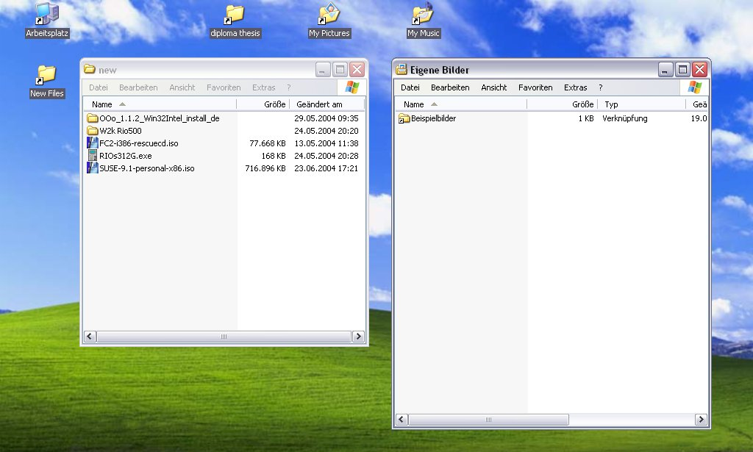
This really is the way for computer novices and just about everyone who does not really want to go in-depth with his computer. I am pretty sure that 80-90% of the computer users do not need more than 5-7 folders where they put their documents, their pictures, their music files and their videos. Let's add another shortcut for a server or for a folder called "backup" and tell the users to duplicate important stuff there. Do not bother these people with file hierarchies. It is pretty obvious that having some folders, each with a direct link on the desktop, is easier for those people.
One problem remains: if I create a subfolder within "My Pictures", maybe to have all the pictures of my last holidays in the same place, Explorer opens the folder in the same window. And now it's inconsistent: I have my "My Pictures"-folder, here, exactly where it is all the time and now it's gone. I don't want to teach my client to use the "back"-button (after all, I tried to avoid all this navigational stuff). So, what do I do? I check the option "open each folder in a new window" (ironic, isn't it?). And then it's consistent again: on the left, there's the "new"-folder with the pictures from my Digicam, on the right, there's the "My Pictures"-folder and on top of it, there's my new subfolder called "Vienna, June 2004". And here I move my files (see screenshot moving_files_01.png).
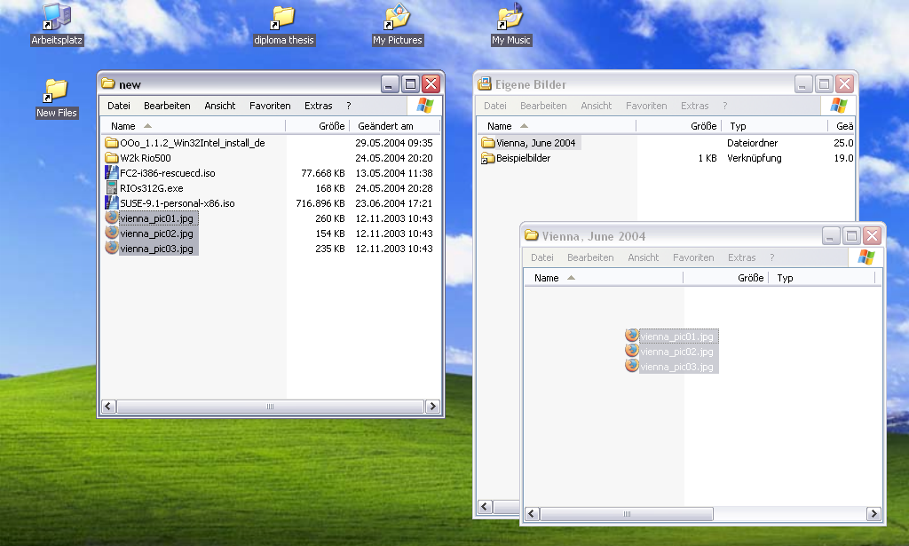
Even better, I can do that without opening the "Vienna, June 2004" folder, just by opening "new" and "My Pictures" and dragging the files over the "Vienna, June 2004" folder (see screenshot moving_files_02.png).
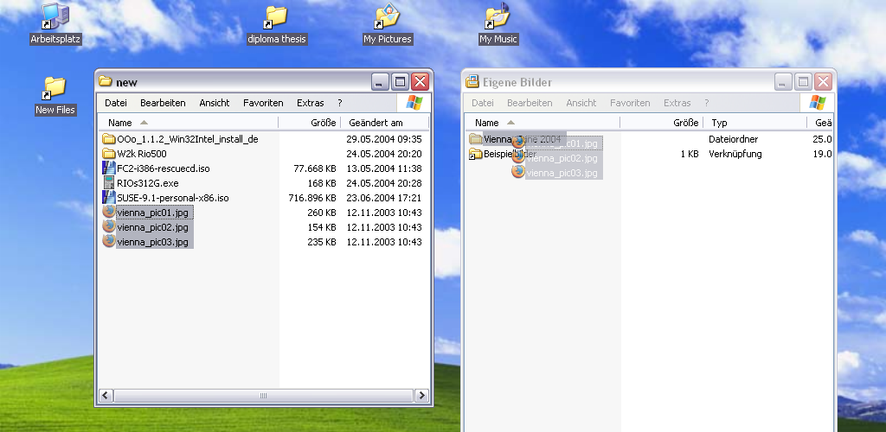
That's why the Gnome team chose to use the spatial mode as the default: expert users who want file hierarchies can change that within 20 seconds. Novice users, on the other hand, should never need to see a file hierarchy. It just makes sense this way. No one switches Windows XP from navigational to spatial (although it is possible, as I have shown). You have to make the option you intend for the novice user the default. That's why they are called novice users: because they don't know how to change a setting they don't like.
Now this is nice and all, but what to do with the intermediate to expert users? I am talking about those people complaining right here on osnews each and every time that they need their file hierarchy, that they have so many files, that they like the organization of their files, that they don't want to open six windows just to get to their stuff and have a cluttered desktop. I, myself, am such a user. I have used file hierarchies for almost a decade now. Being a long-time RedHat/Fedora- (and therefore Gnome-) user (see my review of Fedora Core 2 here), I have been confronted with the spatial Nautilus ever since i installed FC2, right when it came out, about one month ago now. To be honest, in the beginning, I didn't know what to think about spatial Nautilus. What I wrote in my review was: I see spatial browsing more as an additional capability. Sometimes it is really helpful. The trick - for me - is to put some shortcuts to the folders I use regularly on the desktop. Often, I really want to put a file from location A to location B. Works like a charm then.... Basically, I saw what the Gnome team wanted to do. I saw it because I have used similar techniques for my clients for a long time now. I gotta admit, that a lot of what I wrote about configuring a Windows desktop for a novice user in the previous paragraph is influenced by my experienced from last month. I have never "spatialized" Windows desktops that far before I had seen Fedora Core 2. But the trend was obvious: I have used a lot of experience to make the computing for my clients easier. And when I saw Gnome 2.6 and realized that I could just go further incorporating the spatial idea, I was thrilled. But still, I thought: "That's cool for a novice computer user, sadly I can't use it because I have too many files and a file structure that is just too complicated for spatial browsing."
After one month of using Fedora Core 2, i have to admit: I was wrong.
There IS a way to make spatial Nautilus work for me. I tried a lot of things in the last month without any success. I put shortcuts to some of my favourite folders on the desktop, I pretty much used the same techniques I have described before, and sometimes it was really cool dragging and dropping files around, but sometimes it was just annoying when I had to get to a file nested deep in my filesystem. It turned out that I had to change my way of organizing my files. And I will describe what I did exactly to make my filestructure more easier and better to use with spatial Nautilus:
The crucial step: I always had my data partition mounted as /mnt/data and put a symbolic link to that in /home/christian. That's the way I accessed my data partition since I first started to use Linux. But that is not good for spatial Nautilus. The solution to really deal with my folders like objects is mount my data partition as /home/christian/Desktop. This is the single most important step. Remember what they say about spatiality: folders are like real objects! When I mounted my data partition as /mnt/data, I always had to deal with symbolic links and shortcuts to folders. Now, mounted as /home/christian/Desktop, when I create a folder on the desktop, I also create it on my data partition. When i erase a folder in my data partition, it vanishes from my desktop. When I delete a folder icon from my desktop, I erase the entire folder on my data partition. That's as consistent as it can get! That simple change made spatial nautilus for most of my folders the preferred and perfect file managing mode (for all the folders without or with just 1-2 levels of subfolders).
Changing the way I organize my files: I rethought some of my file structuring with the goal to get it to at most 2 levels of subfolders. Ok, many people will say "I don't want to change the way my filestructure is, I am used to what I have created". Well, that's OK, I am just telling what I did. And I did not just do it to make (with a crowbar) spatial Nautilus work, I also feel that I benefited from it. Let's go in-depth:

I had four folders on my data partition, called "arbeit" (german for work), "privat", "media" and "software". "software" was the easiest, because it just contains one level of subfolders for every program that i have. So I just moved the "software"-folder (remember, this is the actual folder, not a link to it, it was already on the desktop because I had mounted my data partition there!) somewhere in the upper right corner of my desktop. "media" was also pretty easy: it contained two subfolders called "musikarchiv" and "videoarchiv". Both if these contained one level of subfolders, the music has one subfolder per band, video has one subfolder per event. I dragged and dropped the "musikarchiv" and the "videoarchiv"-folder from the "media"-folder to the desktop and deleted the "media"-folder afterwards. I opened all three folders and positioned and resized them to my needs.
Now I reworked my "arbeit" (work) folder. It contained three subfolders: "entwuerfe" (drafts), "buchhaltung" (book-keeping) and "kunden" (clients). The first thing I did was take the two files that were in the drafts folder and put them into book-keeping. Why, you may ask? Because the two files are nothing else than my bill drafts, and there was never really a reason why they should not be where the book-keeping is. Afterwards, I deleted the "entwuerfe"-folder. In "buchhaltung" I store all the bills I sent to my clients, my tax computations, some drafts, and so on. The old file structure is displayed here: (screenshot book_keeping_old.png - sorry kde-guys, I had to use konqueror to show the structure, no dissing implied :-) it is just the best program to do that).
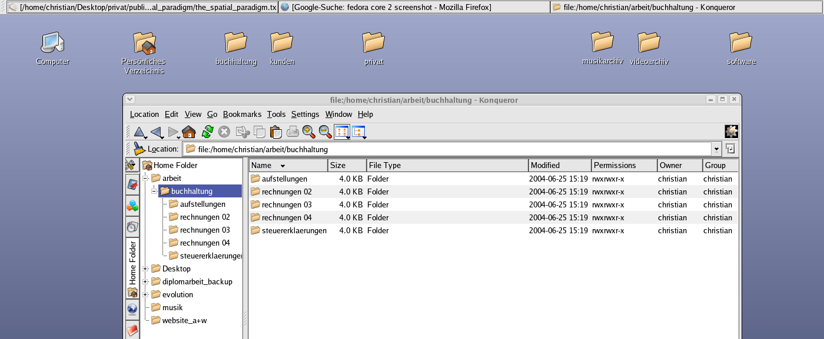
I had three folders, for the bills 2002, 2003, and 2004. And I had one folder, where I kept a summary-spreadsheet of all the income (it's called "aufstellungen"). There were exactly three files in there, one called 2002.sxc, one 2003.sxc, and one 2004.sxc. And I had another folder for my actual tax computations (called "steuererklaerungen"). Too much clutter: I moved the book-keeping-folder out of "arbeit" (no need for a folder when it just contains 2 subfolders...). I moved the summaries and the tax computations to the folders that contained the actual bills. Now it looks like this (screenshot book_keeping_new.png).
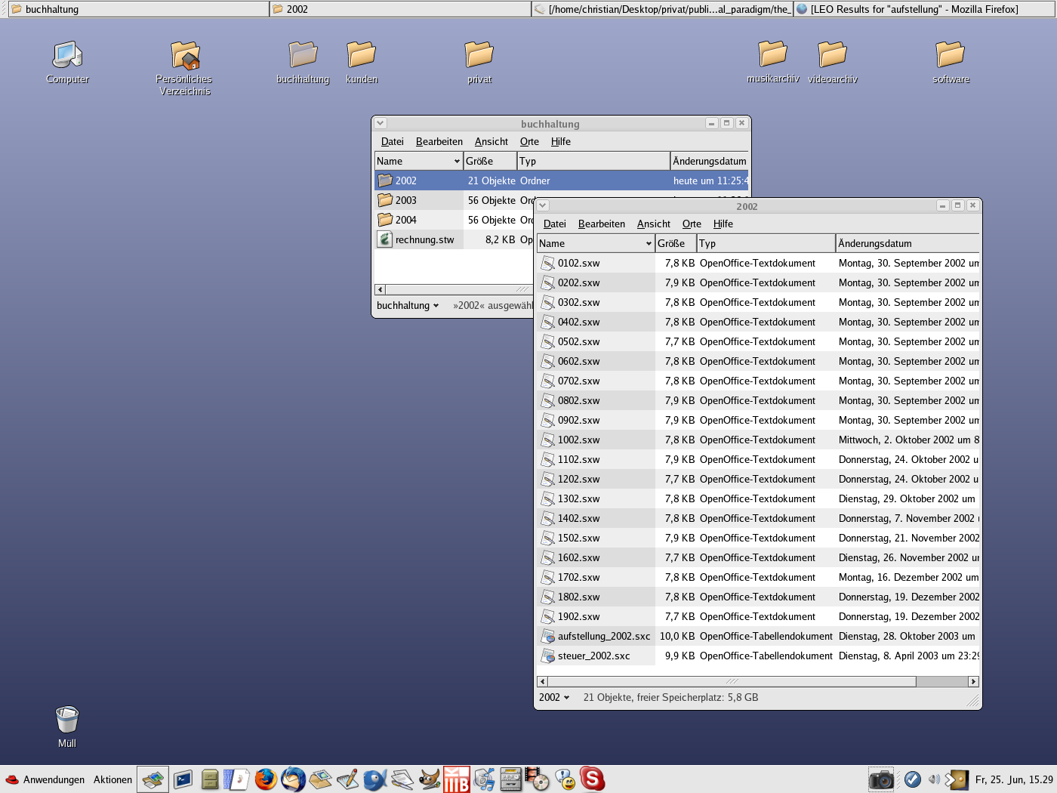
Not only did I clean up my file structure (which was not too complicated in the beginning, I admit, but still...), but also I made it easier for spatial Nautilus, because everything is at most two clicks away now.
My clients-folder was easy, because this is a folder with just one level of subfolders for each of my clients. I also dragged the folder out of "arbeit" and deleted "arbeit" afterwards. One problem remains: I keep local copies of the websites of two of my clients. Here we have a deep file structure like (/home/christian/Desktop)/kunden/client01/web/content/blablabla - at the moment, I am playing with the idea to put those websites into a new folder called (you guessed it) "websites". Hmm, but if I put these pages out of my "clients"-folder, they are separate from my work then... - I am losing my file structure! Well... who cares? I have to back them up anyway and this way, they are easier accessible...

Finally, we have the "private"-folder, where stuff like my diploma, photos, and so on. One major change I did: I created a folder called "dokumente" on the desktop where I now store my diploma, my old university stuff, the recommendation I got from my old company and all the other important documents. Beyond that, I don't want to bore you to death, basically I did the same kind of clean-up that I did to book-keeping. Deep file structures are really not necessary. Don't get me wrong here: I am not saying: "Deep file structures are evil and all of you that have them are idiots because you can't sort your files in a more intelligent way." I am just saying that I do not need them to keep my files organized. I feel that my files are organized better now.
So, that was about what I wanted to say. Let's have a look at my screen now: (screenshot moving_files_article.png) (screenshot screen.png).
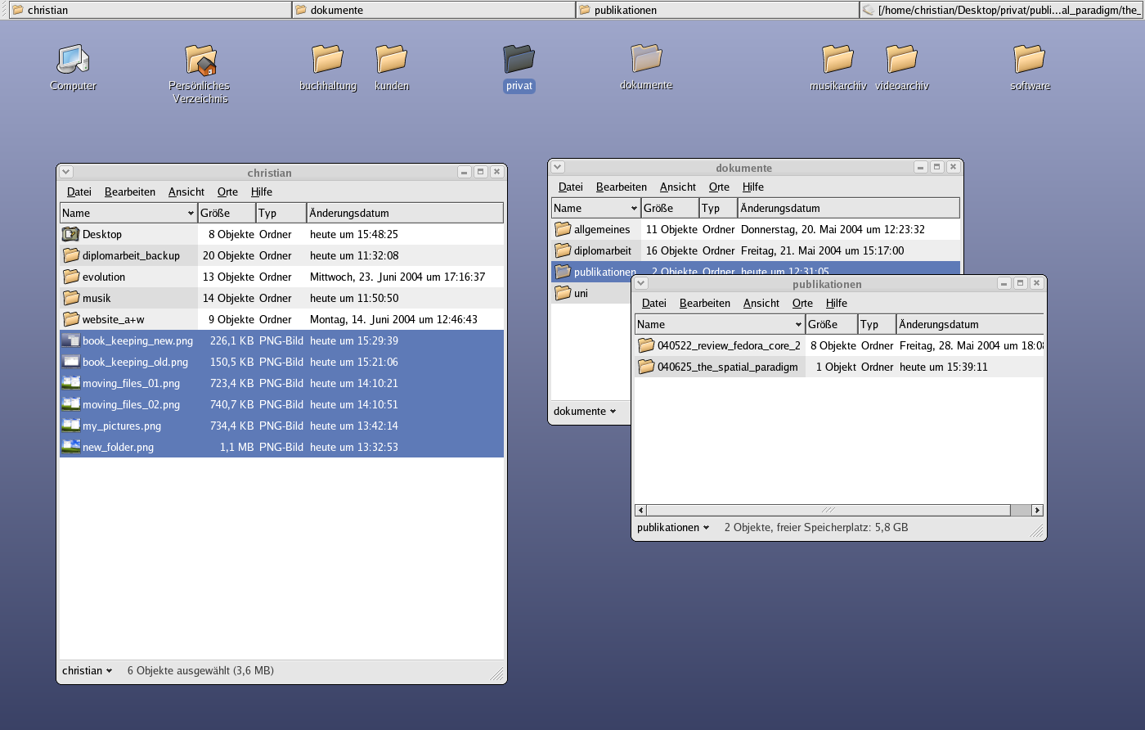
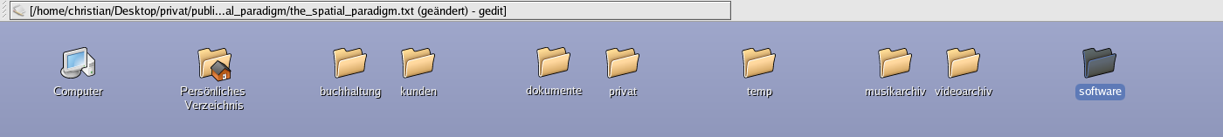
Moving files around has never been that easy and fast for me before. One last tip: a very important button is the "minimize all open windows"-button. When I do webdesign, I always have a lot of windows open. Then, of course, I don't see my folders, so I can't drag and drop. Click to minimize all windows and there are my folders!
OK, that was it, now flame away :-)

About the Author:

Christian Paratschek is a 28 year old self-employed sysadmin and IT-supporter. He uses Fedora and Gnome for his computing needs and is pretty satisfied with this combination, although he has just recently installed Suse 9.1 Personal and found that he likes Suse/KDE a lot more than the last time he tried it...

